**CSE541 Computer Vision**

**Prof. Mehul Raval**

**Gaze Tracking**

**Week 6 Report**

| **Name** | **Enrolment Number** |
| --- | --- |
| Nityam Dixit | AU2040140 |
| Devyash Shah | AU2040152 |
| Kavan Gondalia | AU2040030 |
| Kush Patel | AU2040137 |

# Tasks Performed in the week

* Mount the Camera on Spectacles and provide a continuous source for IR LED.
* Trained a U-net and res-net models on the data that was annotated earlier. The U-Net model was giving better accuracy rather than res-net in our data.
* Tried to tune the hyperparameters and also use different optimizers, layers to increase to accuracy of the model.
* Revisited traditional methods and algorithms to compare with the Neural Network approach.
* Implemented RANSAC algorithm with the preprocessed images and check which performs better, U-Net of RANSAC.

# Findings and results:

* Both U-Net and RANSAC give quite accurate results but RANSAC runs faster than U-Net.
* Due to low computational requirement, RANSAC is able to give more frame rate than U-Net however with more amount of data, U-Net will give better results.

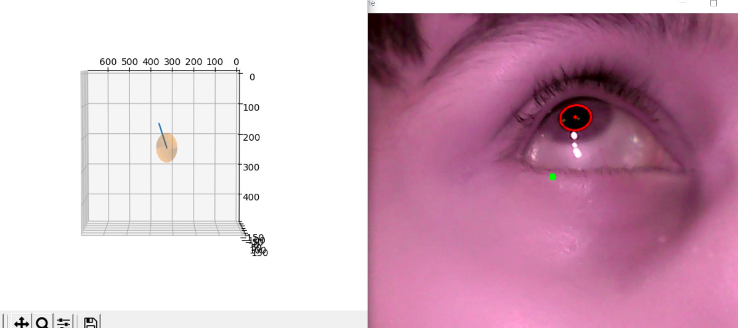

The vector plotted which shows gaze direction.

